<https://github.com/fiamardar/FLCD> -> GitHub Repository Link

Lab 4

Finite Automata class

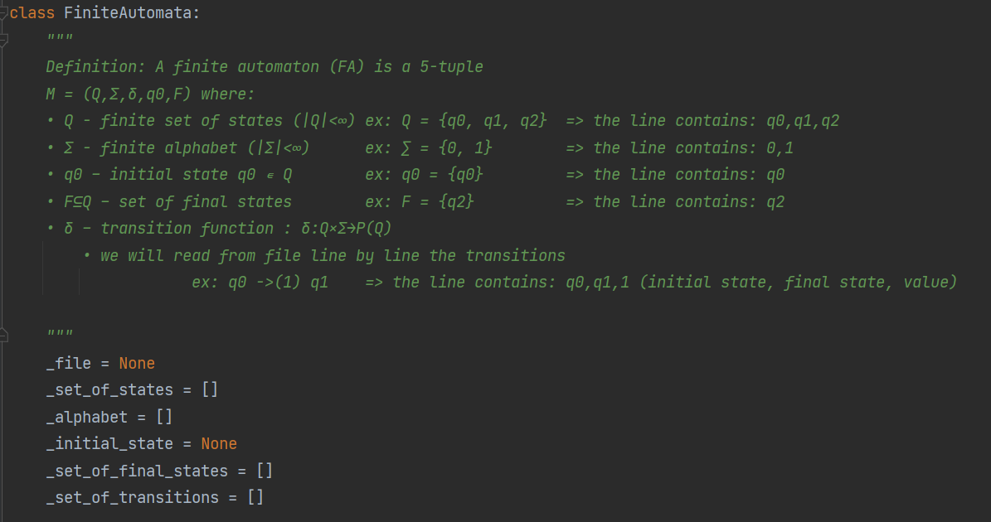

Stores the set of states, the alphabet, the initial state, the set of final states and the set of transitions. It also receives the name of the file from where we want to read the FA.

It contains the function to check if a sequence is accepted by the FA:

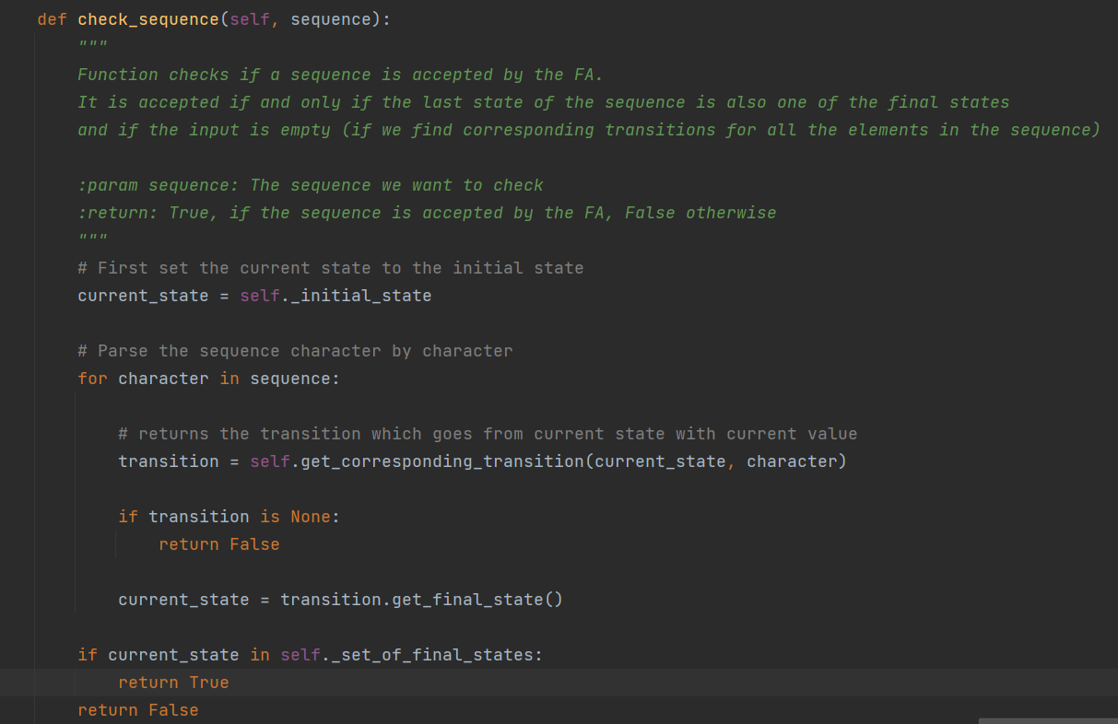

FA.in file:

**Lexic**:

States (including startstates, initialstates, endstates and finalstates):

* a sequence representing the name of the state

(ex: could be any letter P, Q, R or any sequence P1, P2, P3)

**Sintactical rules:**

The program will contain at least 5 lines:

* The first line will contain all the states separated by space
* The second line will contain the alphabet, the symbols are separated by space
* The third line will contain the initial state
* The fourth line will contain the final states separated by space
* The next lines until the end of the file will represent each transition:
  + A transition line contains the starting state of the transition, followed by space, followed by the end state of the transition, followed by space, followed by the symbol value of the transition

**EBNF**:

program = line1 “\n” line2 “\n” line3 “\n” line4 “\n” transitionslines

line1 = STATE | STATE “ “

line2 = symbol | symbol “ “

line3 = INITIALSTATE

line4 = FINALSTATE | FINALSTATE “ “

transitionslines = transition | transition “\n”

transition = STARTSTATE “ “ ENDSTATE “ “ symbol

**FA_integer.in (The file with FA for integer)**

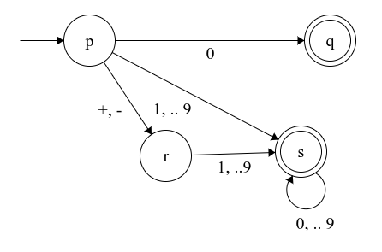

p q r s  
+ - 0 1 2 3 4 5 6 7 8 9  
p  
q s  
p q 0  
p s 1  
p s 2  
p s 3  
p s 4  
p s 5  
p s 6  
p s 7  
p s 8  
p s 9  
p r +  
p r -  
r s 1  
r s 2  
r s 3  
r s 4  
r s 5  
r s 6  
r s 7  
r s 8  
r s 9  
s s 0  
s s 1  
s s 2  
s s 3  
s s 4  
s s 5  
s s 6  
s s 7  
s s 8  
s s 9

**FA_identifier.in (The file with FA for identifier)**

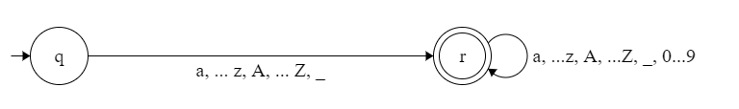

q r  
a b c d e f g h i j k l m n o p q r s t u v w x y z A B C D E F G H I J K L M N O P Q R S T U V W X Y Z 0 1 2 3 4 5 6 7 8 9 - _  
q  
r  
q r a  
q r b  
q r c  
q r d  
q r e  
q r f  
q r g  
q r h  
q r i  
q r j  
q r k  
q r l  
q r m  
q r n  
q r o  
q r p  
q r q  
q r r  
q r s  
q r t  
q r u  
q r v  
q r w  
q r x  
q r y  
q r z  
q r A  
q r B  
q r C  
q r D  
q r E  
q r F  
q r G  
q r H  
q r I  
q r J  
q r K  
q r L  
q r M  
q r N  
q r O  
q r P  
q r Q  
q r R  
q r S  
q r T  
q r U  
q r V  
q r W  
q r X  
q r Y  
q r Z  
q r _  
r r a  
r r b  
r r c  
r r d  
r r e  
r r f  
r r g  
r r h  
r r i  
r r j  
r r k  
r r l  
r r m  
r r n  
r r o  
r r p  
r r q  
r r r  
r r s  
r r t  
r r u  
r r v  
r r w  
r r x  
r r y  
r r z  
r r A  
r r B  
r r C  
r r D  
r r E  
r r F  
r r G  
r r H  
r r I  
r r J  
r r K  
r r L  
r r M  
r r N  
r r O  
r r P  
r r Q  
r r R  
r r S  
r r T  
r r U  
r r V  
r r W  
r r X  
r r Y  
r r Z  
r r _  
r r -  
r r 0  
r r 1  
r r 2  
r r 3  
r r 4  
r r 5  
r r 6  
r r 7  
r r 8  
r r 9